BUILD INSTRUCTIONS

The document documents steps to turn the standard stepper hardware, as bought on Amazon, into a Pi Pico controlled/enclosed stepper motion controller with RS485 interface.

1. Open the standard stepper controller. Expect an aluminum spacer to bridge the gap between the TB67S109AFTG IC and the aluminum heatsink. If you are lucky some thermal compound and/or blob of silicon will keep this spacer in place. For sure you will need to apply thermal compound between this spacer and the heatsink. Non was present on mine.

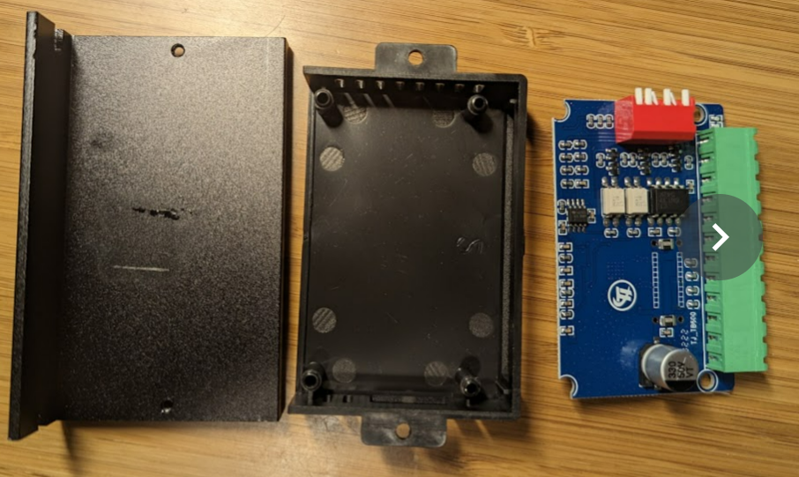

1. Remove one half of the terminal block as depicted below. I used a Dremel to separate the main connector body. Then cutters to free up the individual connectors. This makes it easy to push/remove them when heating up with a soldering iron. Clean the pads.

1. Print the new enclosure. CAD files and print files are provided. I used PLA. The new enclosure is a little taller to make room for the Pi Pico. It has PCB stand-off for the PiPico, a hole on the side to allow Pi Pico USB access, and a pedistole for the terminal block for external RS485 and optocoupler connectivity .

1. Glue the terminal block on top of the pedestal with some epoxy.
2. Mount the Pi Pico with M2 screws to the dedicated stand-offs.
3. Perform all the wiring per wiring diagram. I used 30AWG enameled copper wire. You can use tiny colored glass seed beads for color coding ;o).

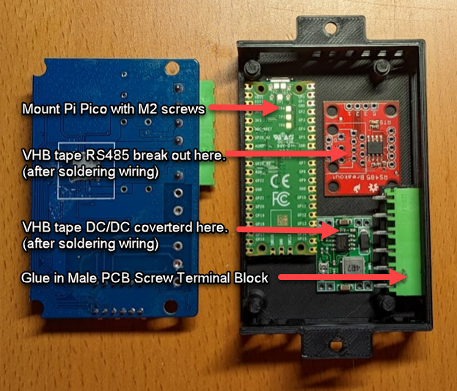

1. After wiring is completed, attached the DC/DC and RS485 converter PCB to the ceiling of the enclosure with double sided VHB tape.

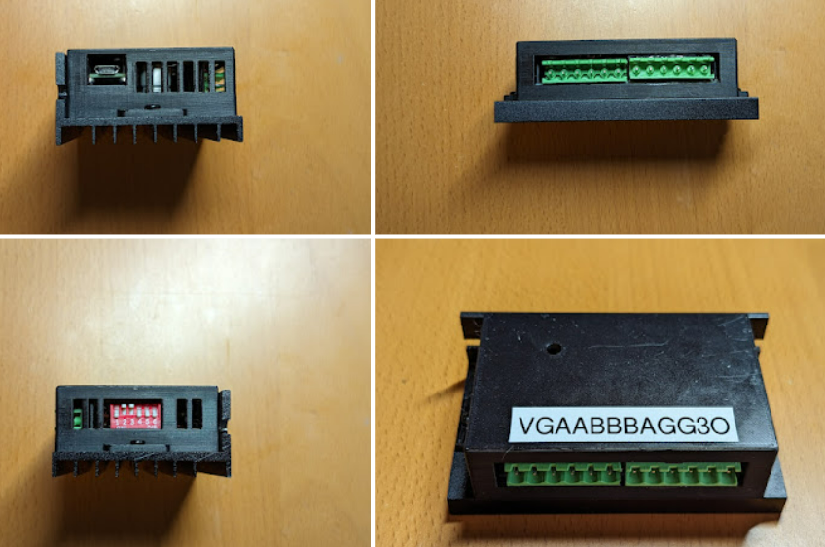

1. Don’t forget to add additional thermal compound when needed.